ASSIGNMENT – 2.1
NAME: R SRIJA
HALLTICKET NUMBER:2303A51043
BATCH:01
Task 1: Statistical Summary for Survey Data
❖ Scenario:
You are a data analyst intern working with survey responses stored as numerical lists.
❖ Task:
Use Google Gemini in Colab to generate a Python function that reads a list of numbers and calculates the mean, minimum, and maximum values.
❖ Expected Output:
➢ Correct Python function
➢ Output shown in Colab
➢ Screenshot of Gemini prompt and result
CODE:
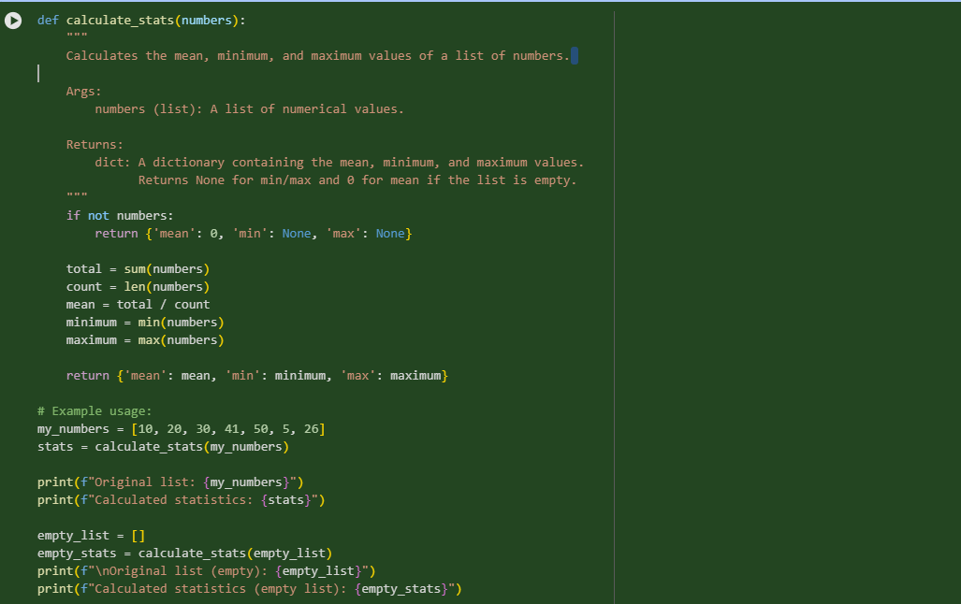
OUTPUT:
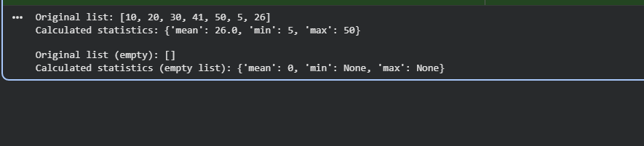
Task 2: Armstrong Number – AI Comparison
❖ Scenario:
You are evaluating AI tools for numeric validation logic.
❖ Task:
Generate an Armstrong number checker using Gemini and GitHub
Copilot.
Compare their outputs, logic style, and clarity.
❖ Expected Output:
➢ Side-by-side comparison table
➢ Screenshots of prompts and generated code
CODE:
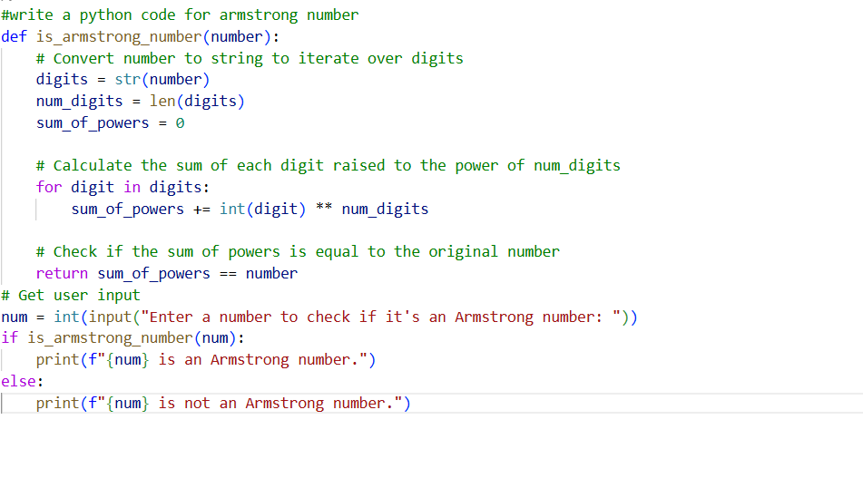

OUTPUT:

Task 3: Leap Year Validation Using Cursor AI
❖ Scenario:
You are validating a calendar module for a backend system.
❖ Task:
Use Cursor AI to generate a Python program that checks whether a given
year is a leap year.
Use at least two different prompts and observe changes in code.
❖ Expected Output:
➢ Two versions of code
➢ Sample inputs/outputs
CODE:
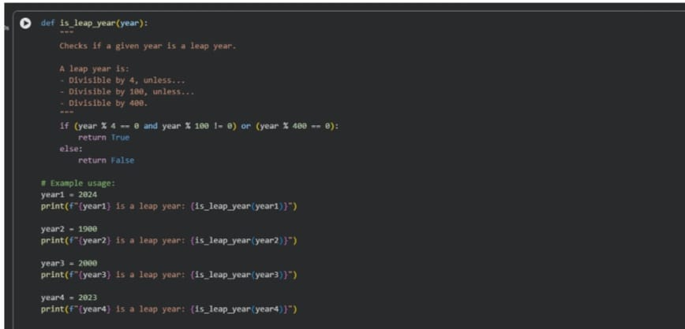
OUTPUT:
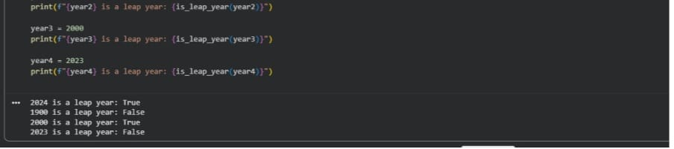
Task 4: Student Logic + AI Refactoring (Odd/Even Sum)
❖ Scenario:
Company policy requires developers to write logic before using AI.
❖ Task:
Write a Python program that calculates the sum of odd and even numbers
in a tuple, then refactor it using any AI tool.
❖ Expected Output:
➢ Original code
➢ Refactored code
➢ Explanation of improvements
CODE:
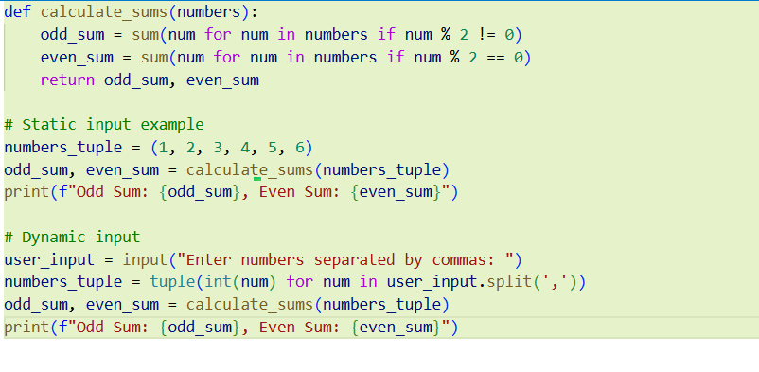
OUTPUT:
